# MOVEit Automation API desktop tool

## Problem statement:

We need to create a tool to leverage the new API for provisioning clients. This tool should provide a user-friendly way to make calls to the API, send the appropriate payload and display the results of the provisioning process in a visual manner.

## Objectives:

1. Provide a seamless and secure interaction with the MOVEit Automation API.
2. Align tool with GTP security standards.

## Functional requirements:

1. FR 1: Ability to execute the MOVEit client provisioning process by providing information about clients and users in a user-friendly manner.
2. FR 2: Ability to visualize the results of the client provisioning process in a detailed report.
3. FR 3: Ability to verify that the client provisioning process was successful.
4. FR 4: Provide a secure login form that allows access to the tool to authorized users only.

## Architecture approach

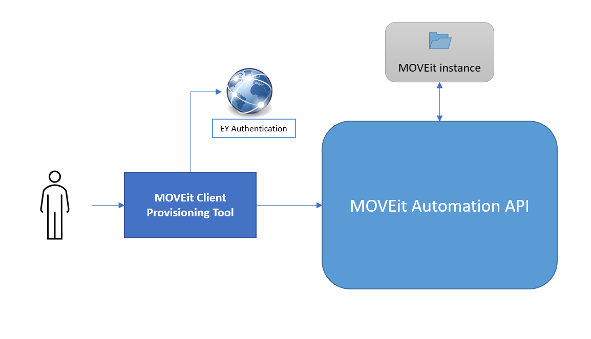

## Mockups

### Login form

* 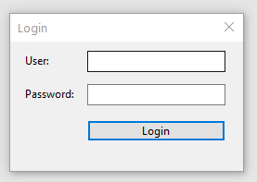Connects to GTP User service.
* Retrieves user details.
* Verifies that role is GTP Platform Admin.
* Provides access to the tool only to Platform Admins.

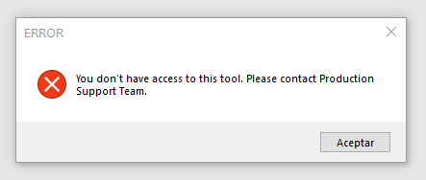

### Main form

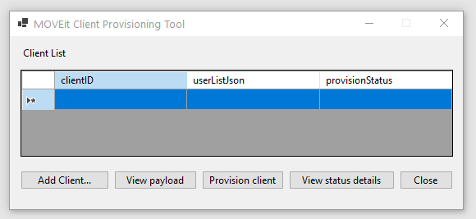

* Provides access to a list of clients to be processed and the status of each process.
* Provides a button to execute the provisioning process
* Provides a button to Add client details

### Add Client form

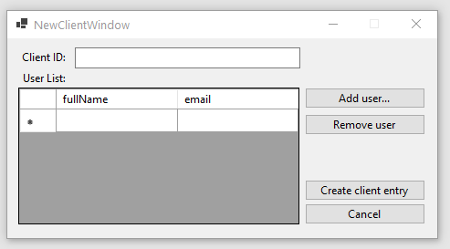

* Provides a form to add client information
* Provides a list of users added under a specific client id

Add user form

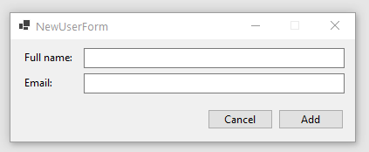

* Simple form to provide user details to be added to a specific client